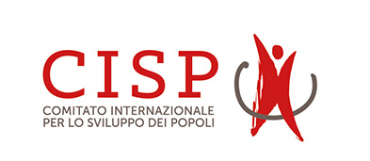 Covered Somalia/Kenya territories

SOMALIA
Available options | Family size | Benefits |  |  |  |  | Family Contribution Per month | Total
 |  | Inpatient | Outpatient | Maternity | Dental | Optical
Option One | M+3
Option two | M+3
Option Three | M+3
Option One | M+04
Option two | M+04
Option Three | M+04
Option One | M+05
Option two | M+05
Option Three | M+05
(Attach official offer/quotation signed/stamped)

KENYA
Available options | Family size | Benefits |  |  |  |  | Family Contribution Per month | Total
 |  | Inpatient | Outpatient | Maternity | Dental | Optical
Option One | M+3
Option two | M+3
Option Three | M+3
Option One | M+04
Option two | M+04
Option Three | M+04
Option One | M+05
Option two | M+05
Option Three | M+05
(Attach official offer/quotation signed/stamped)

Other requirements.
- List of current active hospitals
- Location/district per hospital

GPA

No | Qty | Cover | Benefits | Percentage on salary of staff (%) | Total
Group Personal accident benefits  With PVT and air evacuation.  World wide and 24 hours ( 70 Years Old) | No. staff Approx. 32 | - Accidental death
 |  | Permanent total disability
 |  | - Temporary total disability
 |  | - Funeral expenses
 |  | - Medical expenses
(Attach official offer/quotation signed/stamped)

